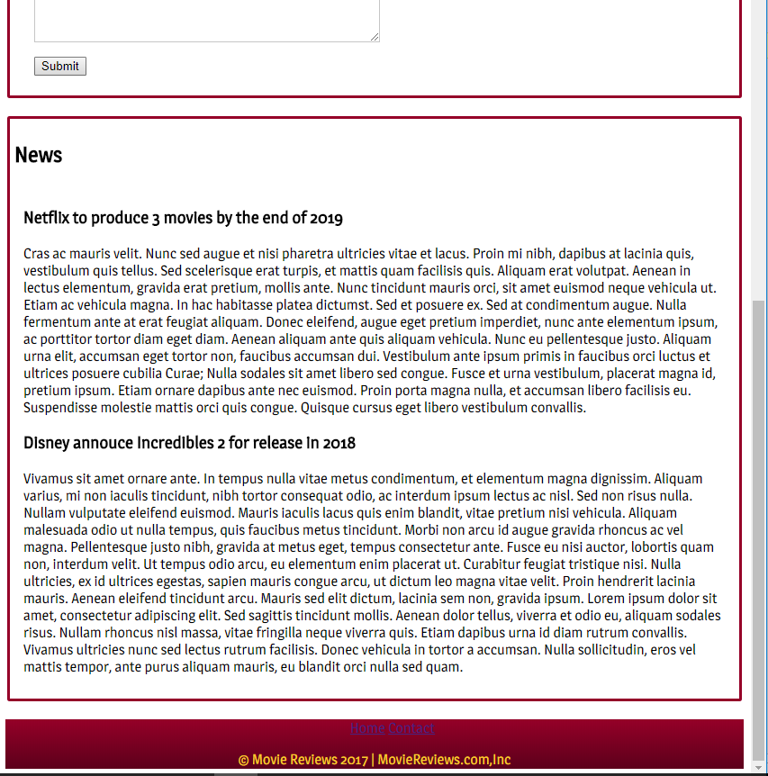

After I made the changes – width = 100%, and no margin-left, Window minimised

After I made the changes – width = 100%, and no margin-left, Full window

